Work Instruction

Student & Sponsor Instalment Plans | N/A

Purpose
This document is intended to give guidance in the setting up and interpreting of student and sponsor instalment plans (and schemes) within SAP.

Prerequisites
Basic knowledge of SAP navigation, customer accounts within SAP and Banner functionality has been assumed.

Procedure
1. Perform one of the following:
To | Go To
Display and interpret the customer master in SAP. | Step 2
Enter payment terms and bank details. | Step 4
Display and interpret customer line items. | Step 5
Altering existing SAP documents – payment methods and due dates. | Step 6
Tuition Instalment Plans. | Step 7
Residence Instalment Plans. | Step 8
Sponsor Instalment Plans. | Step 9
Manually entering an instalment plan onto SAP. | Step 10
Uploading instalment plans from MS Excel ®: | Step 11
Instalment schemes (ad-hoc agreements). | Step 12

2. Display and interpret the customer master in SAP:

Display Customer: Initial Screen
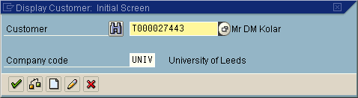
2.1 As required, complete/review the following fields:
Field Name | R/O/C | Description
Customer | R | Enter the customer number.  Example: T000027443

3. Click on .

Display Customer: General data
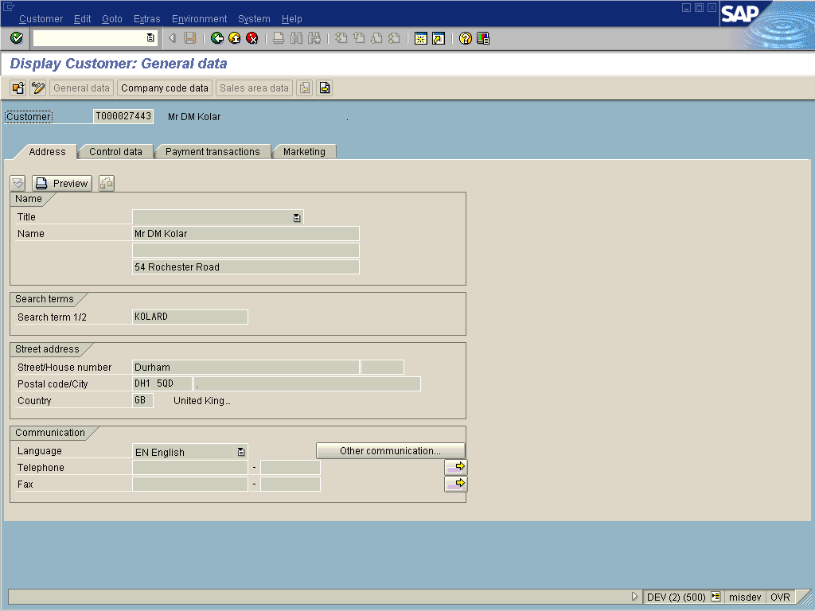
3.1 Click on to display instalment terms (Type of ind. field).

Display Customer: General data
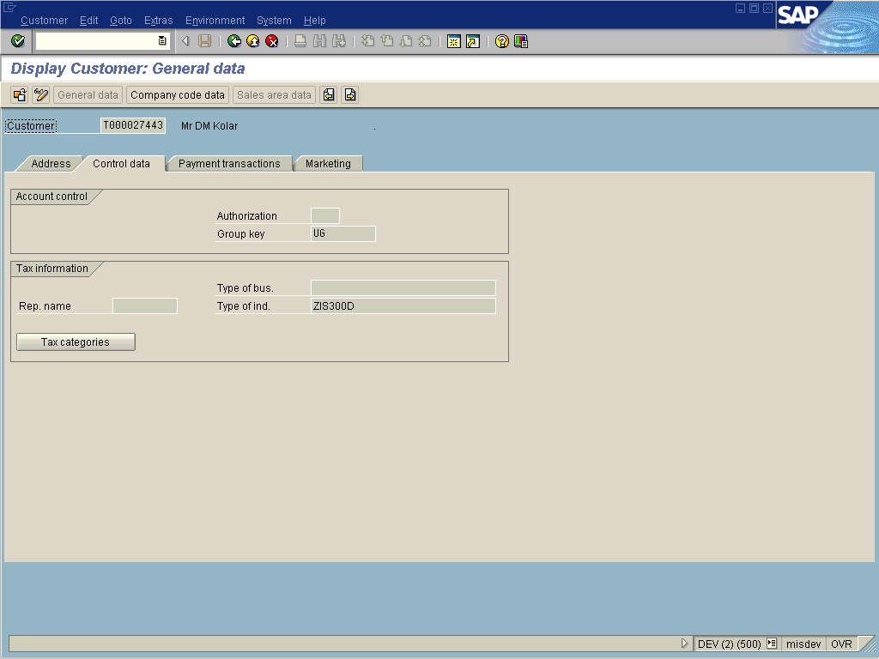
 The instalment term is displayed in the Type of ind. field. The first 4 characters relate to the SAP instalment payment term. The next 2 characters relate to the number of months forward to set the baseline date. The last character relates to the payment method - this can be D, P, C or left blank. This should only be left blank when the payment term ZEOS is being used – here new Banner charges would fall due at the end of session.
3.2 Click on to display existing bank details.

Display Customer: General data
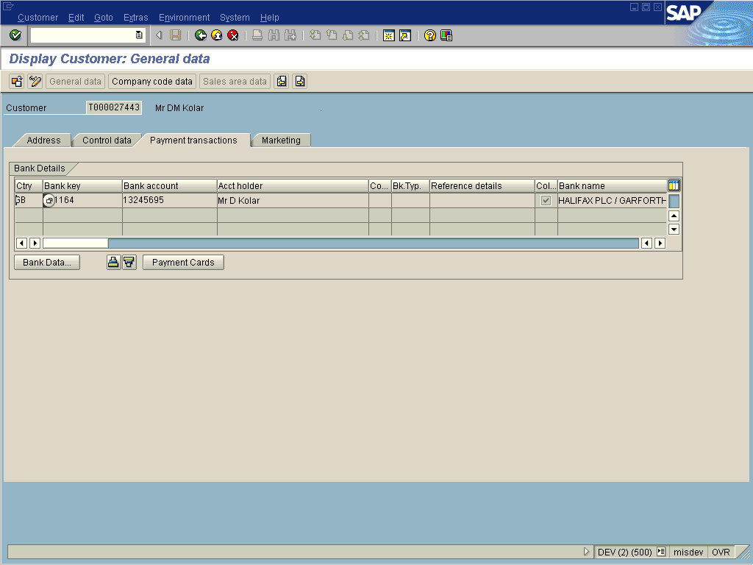
If the Payment transactions tab does not appear there are no bank details stored against the customer master record.
 A is required in the Collect. Auth. box for SAP to attempt a direct debit collection.

4. Enter payment terms and bank details:
4.1 Payment terms are entered onto SAP using transaction code FD02 - Change Customer (Accounting).

Change Customer: Initial Screen
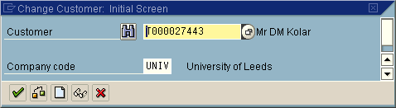
4.2 As required, complete/review the following fields:
Field Name | R/O/C | Description
Customer | R | Enter the customer number.  Example: T000027443

4.3 Click on .

Change Customer: General data
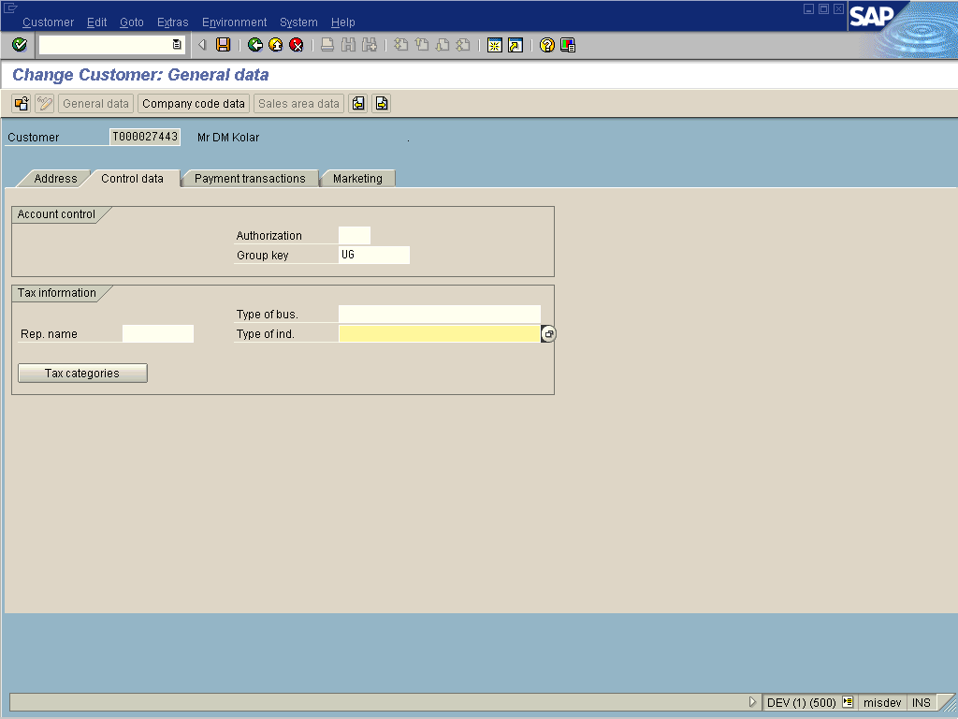
The entry in Type of ind. field is a six or seven character field with the following structure. Please refer to FD02 documentation for full instructions: http://sapinfo.leeds.ac.uk/content/fd02/cc/html/index.htm.
4.4 To update instalment payment terms click on and click on to view the ‘Type of ind.’ field.
4.1 As required, complete/review the following fields:
Field Name | R/O/C | Description
Type of ind. | R | The first 4 characters relate to the SAP instalment payment term.  The next 2 characters relate to the number of months forward to set the baseline date.  The last character relates to the payment method - this can be D, P, C or left blank. This should only be left blank when the payment term ZEOS is being used – here Banner charges would fall due at the end of session.  Example: ZIC200D

 For Direct Debit payers bank account details are also required within SAP.
Full details of the different instalment plans (together with due dates) is available by following the hyperlink: http://www.leeds.ac.uk/mais/sapweb/training/pmtterms.xls

When the Banner and SAS interfaces run in SAP they reference this field on the customer master data and alter the terms applied to transactions based on its values. Leaving these fields blank within Banner (and therefore blank within SAP) will mean that standard payment terms are applied.
Altering the field in SAP will have no affect on existing transactions against the student’s account. Only new transactions from Banner or SAS will be affected automatically.
4.2 Click on to update bank details.

Change Customer: General data
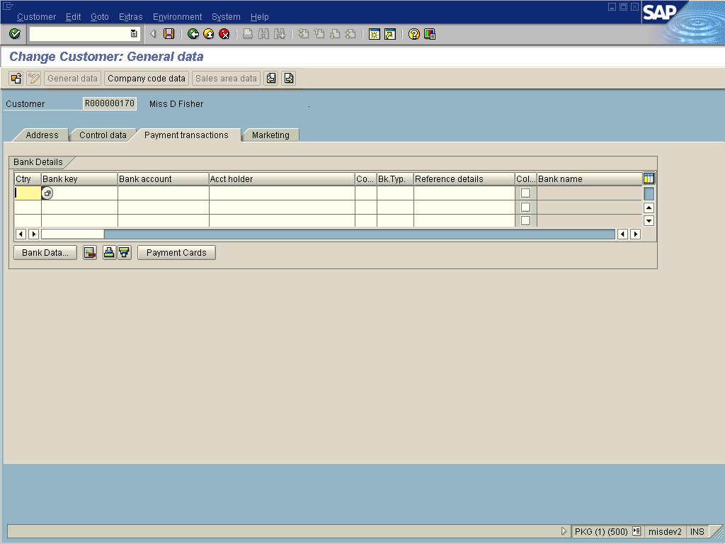
4.3 As required, complete/review the following fields:
Field Name | R/O/C | Description
Ctry | R | Enter the bank country key.  At present direct debit collection is only possible from UK bank accounts.  Example: GB
Bank key | R | Enter the bank key.  Enter the 6-digit sort code.  Example: 205942
Bank account | R | Enter the bank account.  Example: 12345678
Acct holder | O | Enter the name(s) of the account holder.  This entry is optional.  Example: Mr & Mrs A Fisher.
Collect. Auth. | R | Enter the collection authority.  This check is required for SAP to attempt to make a direct debit collection.  Example: Select .

4.4 Click on .
5. Display and interpret customer line items:
5.1 Customer line items are accessed within SAP using transaction code FBL5N.

Customer Line Item Display
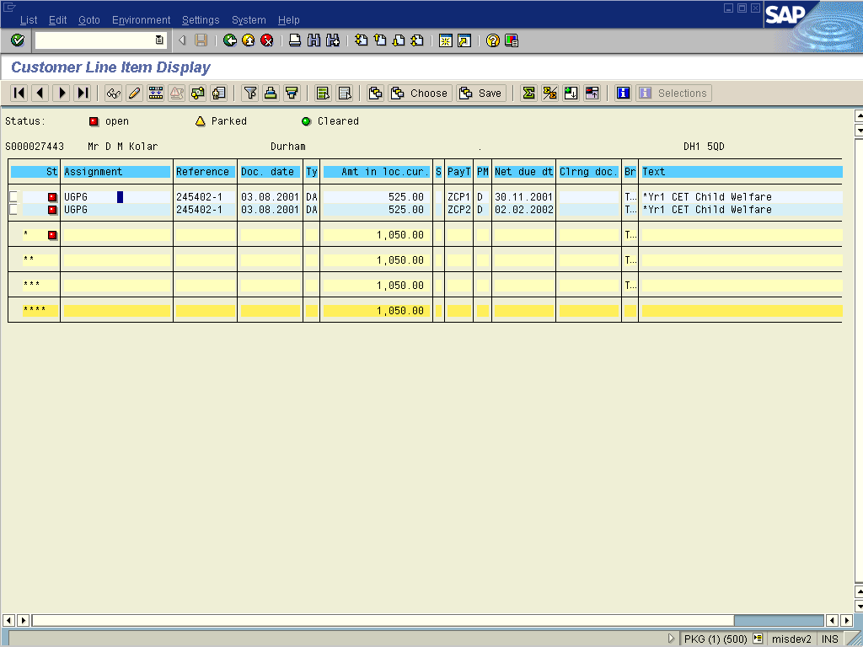
The above line item display shows a student contributors two part instalment scheme. The charge of £1,050 has originated in Banner and has been entered into SAP through the interface. The charge has been split into two lines on the customer account with different ‘due dates’ (30.11.2001 and 02.02.2002 in the example.) You can see that these two lines are generated from one Banner transaction, as the Banner transaction reference (245402-1) is the same for both lines.
5.2 Payment Methods: In the above display PM is used to display the payment methods applied against each transaction. For customer accounts there are three relevant methods.
Payment Method | Description
D | Direct debit collection
P | Credit card collection
C | Here no specific method is assigned; the student is responsible for making arrangements to pay. (For direct debit and credit cards we are responsible for the collection of monies).

5.3 Net due date: This date represents the day when a particular charge or credit falls due. This is a dynamically calculated field and is calculated using the baseline date and days fields.
5.4 From the line item display, drill down (double clicking on one line item) to display these additional fields. The due date of 30.11.2001 is calculated as 121 days from 01.08.2001.

Display Document: Line Item 002
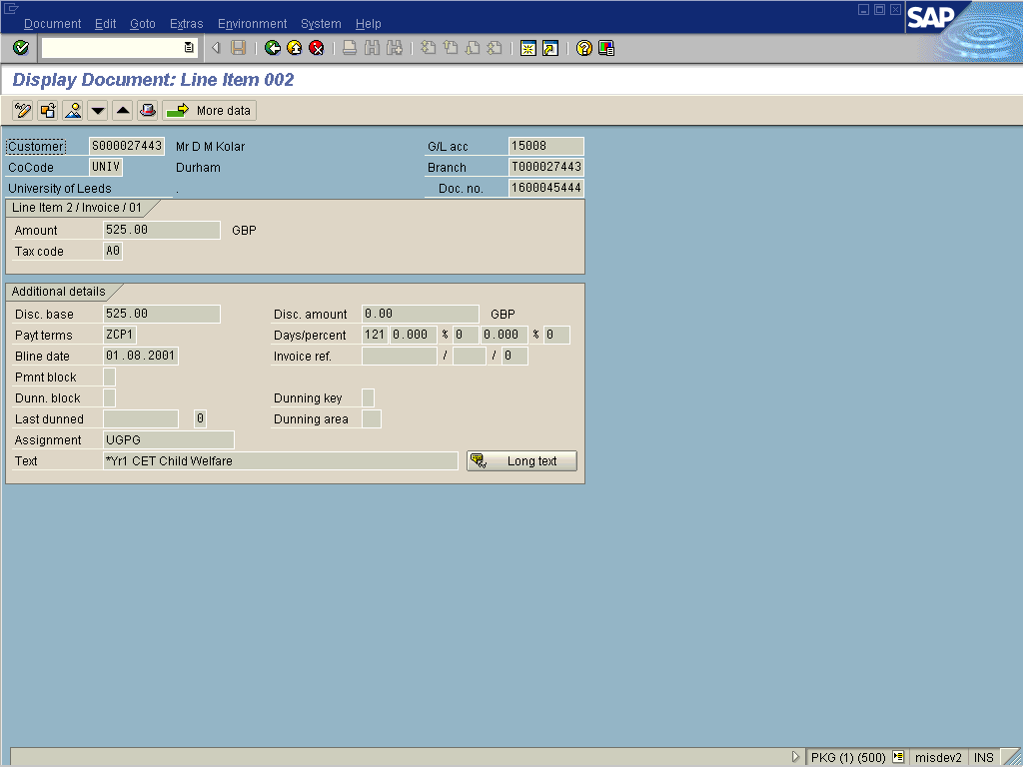
A ‘V’ is required in the Invoice ref field to trigger this calculation when entering a credit against a customer account. Without a V in the Invoice ref field, credits fall due on the Baseline date!
The logic that applies to charges also applies to credits. In our example as Cambridgeshire CCSLC are paying £525 a credit would be applied to the students account for this sum.

Customer Line Item Display
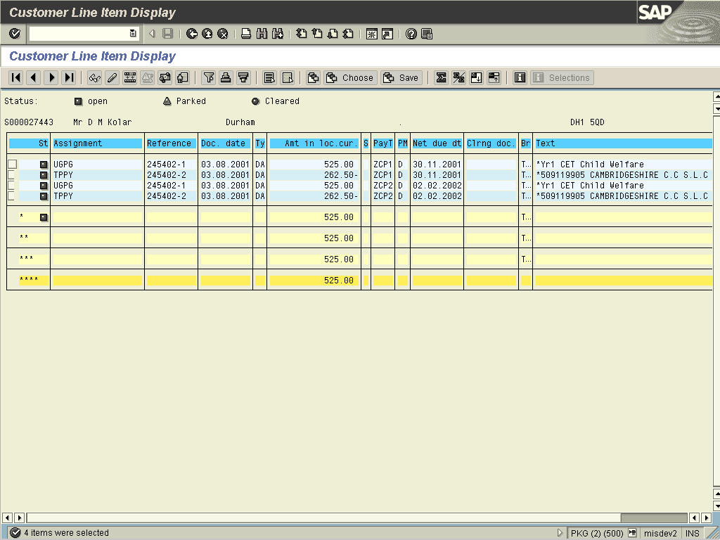
The credits and debits fall due on the same day so the student owes £272.50 (525.00 – 262.50) on the 30.11.2001 and £272.50 on 02.02.2002. The direct debit collection program would collect these net figures.
6. Altering existing SAP documents – payment methods and due dates:
6.1 From the customer line item display (transaction code FBL5N); place the cursor on the line to alter and click on .

Change Document: Line Item 002
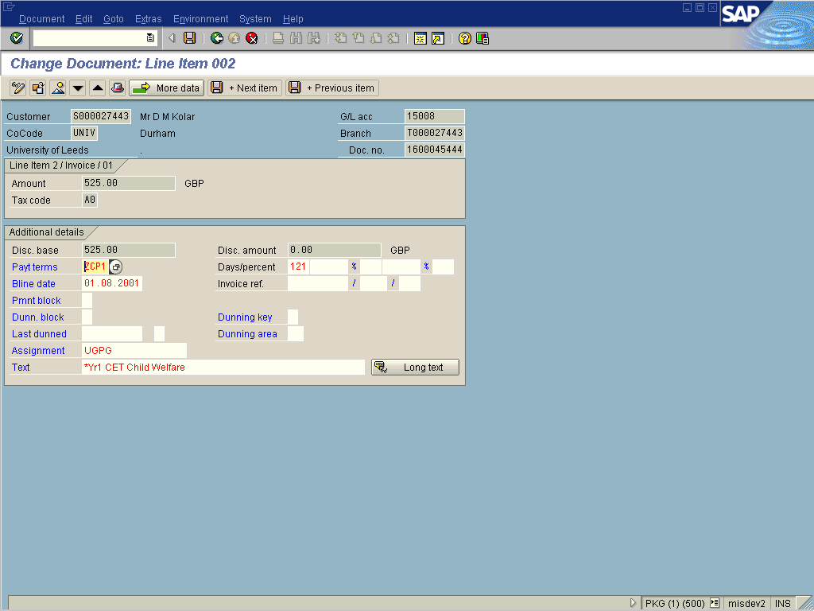
6.2 Fields with a white background can be edited. For example to alter the due date, either the Bline date or Days/percent fields should be amended. In our example the charge of £525 falls due on 30.11.2001. To alter this to fall due on 30.12.2001 you could alter the days to 151 or the baseline date to 31.08.2001.

Change Document: Line Item 002
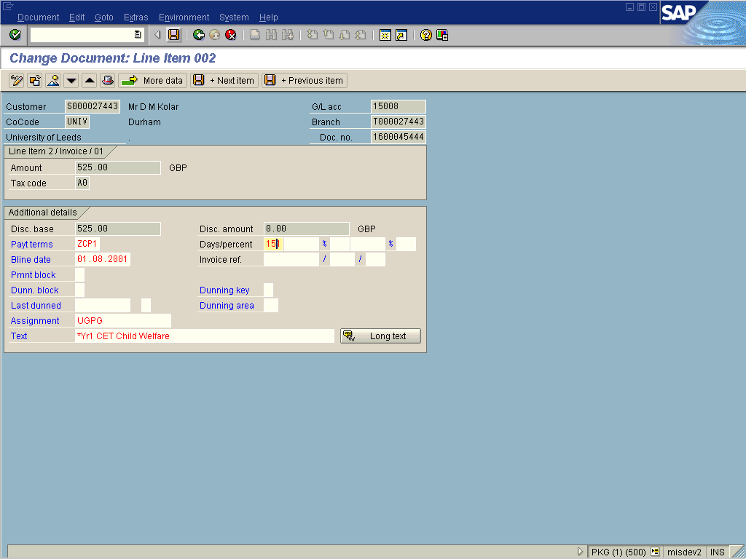
Remember to click on to apply any changes.
6.3 To alter the payment method click on .

Additional Details for Line Item 002
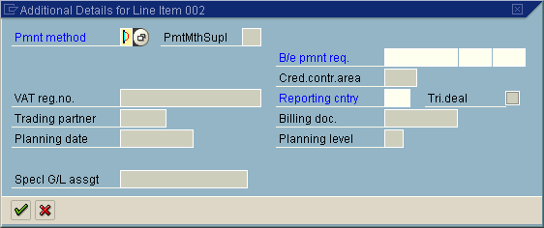
6.4 As required, complete/review the following fields:
Field Name | R/O/C | Description
Pmnt method | O | Enter an appropriate payment method.

6.5 Click on when changes have been made.
6.6 Display the changed settings by selecting List ➔ Refresh from the menu.
7. Tuition Instalment Plans: Three tuition instalment schemes have been set up on SAP.
7.1 ZIC2 – Student contributors two part instalment scheme. This consists of two equal instalments due 30th November and 2nd February.
Banner entry | 1st Collection  (ZCP1) | 2nd Collection  (ZCP2) | Baseline Date
ZIC200 | 30 Nov | 04 Feb | 01 Aug

The Banner entries noted above exclude the payment method suffix. (P, D or blank).
7.2 ZIS3 – Self funded three-part instalment scheme. This consists of three equal instalments due immediately, 28th January and 22nd April.
Banner entry | 1st Collection  (ZSP1) | 2nd Collection  (ZSP2) | 3rd Collection  (ZSP3) | Baseline Date
ZIS300 | Immediately | 28 Jan | 22 Apr | 01 Aug
The payment method for the amount due immediately (ZSP1) is ‘C’ irrespective of the term entered against ZIS3. As payment for this sum is made when applying for the instalment plan it is not collected automatically by direct debit or credit card.
7.3 ZIT3 – Self funded three-part instalment scheme. This consists of three equal instalments due immediately, 1st January and 1st May April (or subsequent months by incrementing the baseline date in monthly intervals starting from 1st August).
Banner entry | 1st Collection  (ZSP1) | 2nd Collection  (ZTP2) | 3rd Collection  (ZTP3) | Baseline Date
ZIST00 | Immediately | 01 Jan | 01 May | 01 Aug
ZIT301 | Immediately | 01 Feb | 01 Jun | 01 Sep
ZIT302 | Immediately | 01 Mar | 01 Jul | 01 Oct
ZIT303 | Immediately | 01 Apr | 01 Aug | 01 Nov
ZIT304 | Immediately | 01 May | 01 Sep | 01 Dec
ZIT305 | Immediately | 01 Jun | 01 Oct | 01 Jan
ZIT306 | Immediately | 01 Jul | 01 Nov | 01 Feb
ZIT307 | Immediately | 01 Aug | 01 Dec | 01 Mar
ZIT308 | Immediately | 01 Sep | 01 Jan | 01 Apr
ZIT309 | Immediately | 01 Oct | 01 Feb | 01 May
ZIT310 | Immediately | 01 Nov | 01 Mar | 01 Jun
ZIT311 | Immediately | 01 Dec | 01 Apr | 01 Jul
The payment method for the amount due immediately (ZSP1) is ‘C’ irrespective of the term entered against ZIT3. As payment for this sum is made when applying for the instalment plan it is not collected automatically by direct debit or credit card.
8. Residence Instalment Plans: Three residence instalment plans have been set up on SAP.
8.1 ZIR6 – Residences six part instalment scheme. This consists of six equal instalments due 1st November, December, February, March, May and June.
8.2 ZIR5 – Residences five part instalment scheme. This consists of five equal instalments due 1st December, February, March, May and June.
8.3 ZIR9 – Residences nine part instalment scheme. Consists of nine equal instalments due 1st of each month from 1st November through to 1st July.
It is not anticipated that the default baseline date of 1st August is amended under the residence instalment schemes.
As residence instalment plans do not directly relate to charges made by the accommodation system (SAS), ALL residence instalment plans have to be entered onto SAP either manually (see Step 10) or via the instalment upload program (see Step 11). For instalment payers, charges for rent, utilities and amenities from the accommodation system do not fall due until the end of session (30th June.). Any other charges (which are outside the instalment plan) fall due within seven days as normal.
9. Sponsor Instalment Plans. Two sponsor instalment schemes have been set up on SAP.
9.1 ZIP2 – Sponsor two part instalment scheme. This consists of two equal instalments due 15th December and 15th May.
9.2 ZIP3 – Sponsor three part instalment scheme. This consists of three equal instalments due 15th November, 15th February and 15th May.
It is not anticipated that the default baseline date of 1st August is amended under the sponsor instalment schemes.
Sponsor instalment terms are not entered onto Banner as the ROAUSDF screen is not available to sponsors. Entry of sponsor instalment terms is made directly onto SAP using transaction code FD02.
10. Manually entering an instalment plan onto SAP:
10.1 Instalment plans can be manually entered onto SAP directly or uploaded from a spreadsheet (see Step 11). Entry (either manually or via a spreadsheet) into SAP will be required for all residence instalment plans or when the payment terms are entered onto Banner after the tuition charges have been applied.
See Step 12 for details on instalment schemes (ad-hoc agreements).
10.2 When entering an instalment plan two entries need to be made against the students account. Both a debit item (which SAP splits into multiple items with different due dates) and a matching credit item are entered so that the account balance remains unaltered.
10.3 Manual plans are entered using transaction code F-21 – Enter Transfer Posting.

Enter Transfer Posting: Header Data
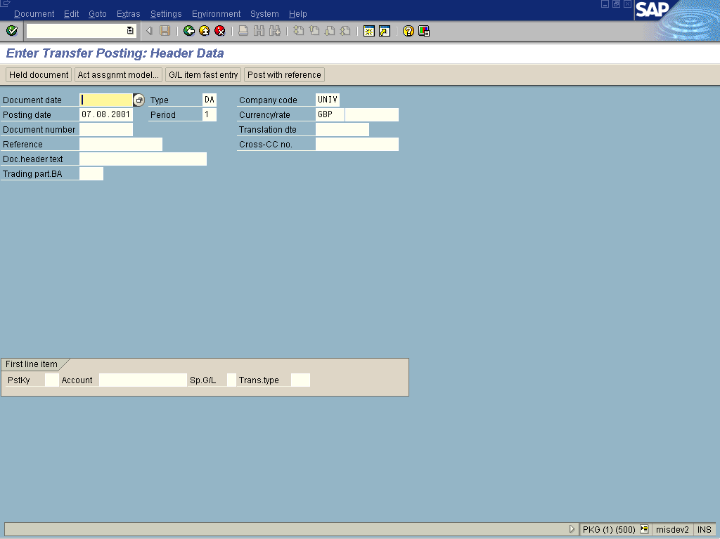
10.4 As required, complete/review the following fields:
Field Name | R/O/C | Description
Document date | R | Enter the document date.  Example: 07.08.01
Reference | R | Enter the reference.  Example: Instlmnt
Doc.header text | R | Enter the document header text.  Example: Instalment Scheme
PstKey | R | Enter the posting key.  Posting key 01 is used to enter an invoice against a customer account.  Example: 01
Account | R | Enter the account.  Example: R000003791
10.5 Click on .

Enter Customer document: Add Customer item
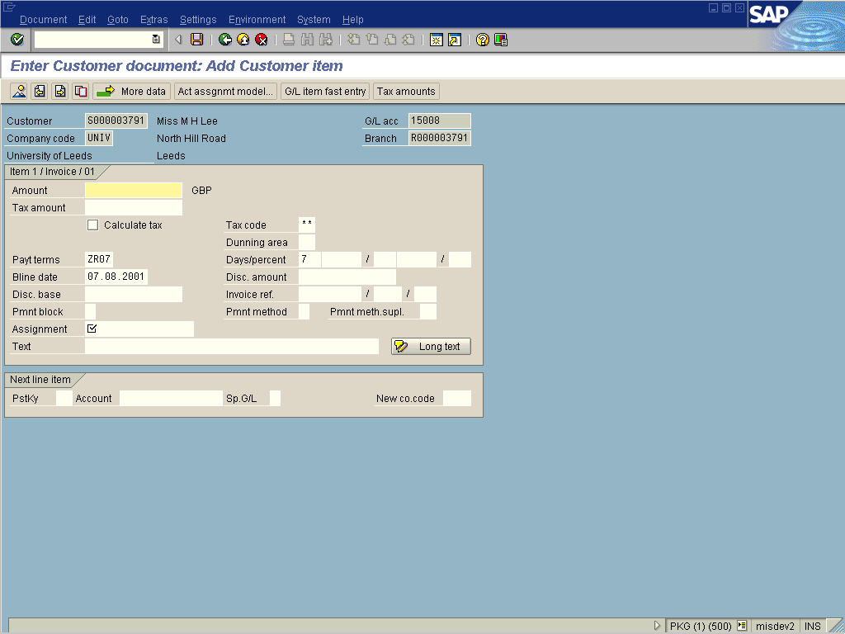
10.6 As required, complete/review the following fields:
Field Name | R/O/C | Description
Amount | R | Enter the amount.  Example: 1100
Payt terms | R | Enter the payment terms.  Select the instalment plan you want to enter against the student. This example uses the residence six part scheme.  Example: ZIR6
Bline date | R | Enter the baseIine date.  Example: 01.08.2001
Pmnt method | O | Enter the payment method  Enter D for direct debit, P for credit card or C where the customer will pay by some other method.  Example: D
Assignment | R | Enter the assignment.  Example: Instlmnt
Text | R | Enter the text.  Example: *Instalment Scheme
PstKy | R | Enter the posting key.  Posting key 11 is used to enter a credit memo against a customer account.  Example: 11
Account | R | Enter the account.  Example: R000003791

10.7 Click on .
10.8 As required, complete/review the following fields:
Field Name | R/O/C | Description
Amount | R | Enter the amount.  Example: 1100
BIine date | R | Enter the baseIine date.  This is the date that the credit will become ‘due’.  Example: 30.06.02
Assignment | R | Enter the assignment.  Example: Instlmnt
Text | R | Enter the text.  Example: *Instalment Scheme

10.9 Click on to save the document.
You can simulate the document (before saving) by following the menu path Document ➔ Simulate.

Customer Line Item Display
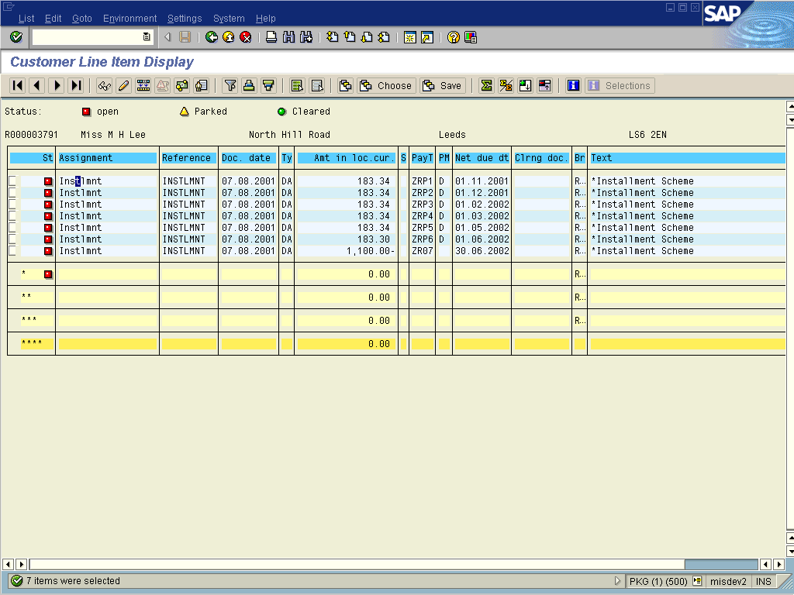
In our example seven lines are created against the students account; the six debit lines collectable by direct debit and the balancing credit of £1,100. The balance on the students account is unaffected by the instalment plan and remains at zero.
11. Uploading instalment plans from MS Excel ®: An upload program has been written which uploads details from a spreadsheet and creates a batch-input session. The format of the spreadsheet is as outlined:
11.1 As required, review the following fields:
Customer | Amount | Payment Term | Payment Method | Baseline Date
R200000124 | 1100 | ZIR6 | D | 01/08/01
R200000125 | 1000 | ZIR6 | P | 01/08/01
R200000126 | 900 | ZIR6 | C | 01/08/01
11.2 Enter the details of the instalment plans into the spreadsheet and save the file.
11.3 Use transaction code ZFFH to upload the details into SAP for processing.

Upload of SIMS / SAS Instalment Plans
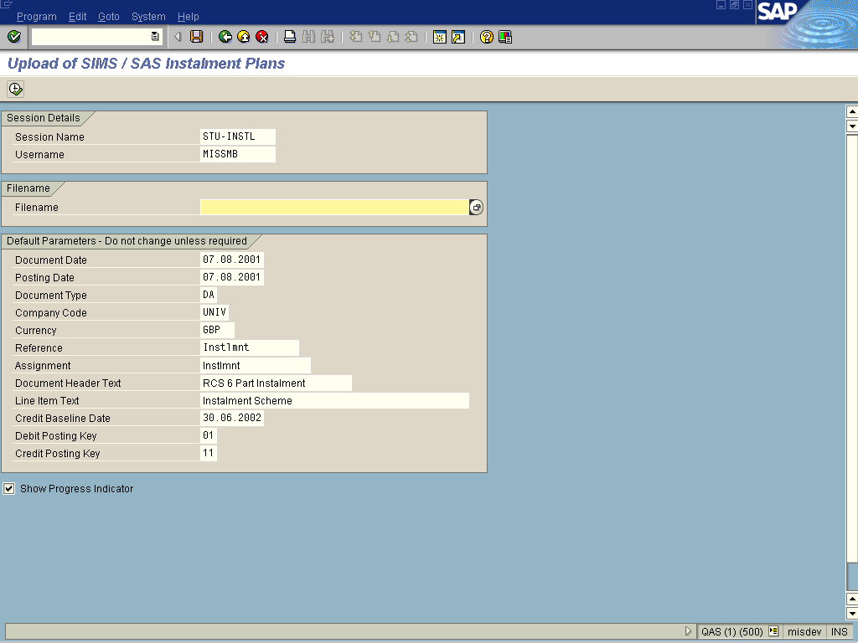
11.4 As required, complete/review the following fields:
Field Name | R/O/C | Description
Filename | R | Enter the filename.  Example: C:\temp\instalmn.xls
Document Header Text | R | Enter the document header text.  Example: Instalment Scheme
Line Item Text | R | Enter the line item text.  Example: Instalment Scheme

11.5 Click on .

Upload of SIMS / SAS Instalment Plans
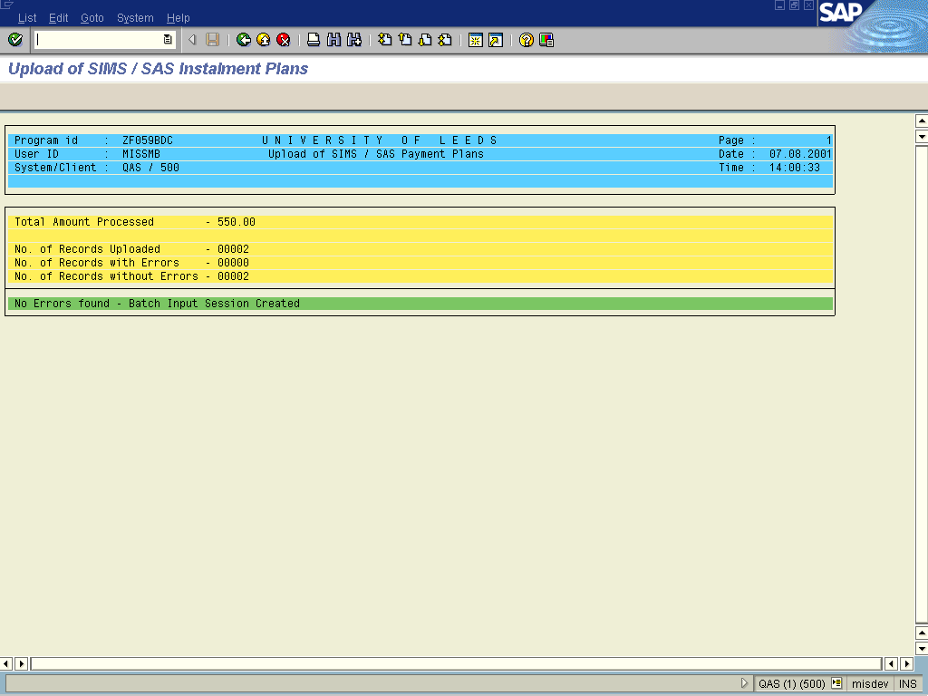
A report displaying any errors, the number of records processed and the total instalment amount is displayed for information. The program creates a batch-input session if no errors exist. This batch-input session is processed in the normal manner using transaction SM35.
12. Instalment schemes (ad-hoc agreements): Where an ad-hoc agreement has been made (which does not coincide with an instalment plan), manual entries are required in SAP. Manual entry allows complete flexibility of the instalment amounts, dates and payment methods.
12.1 The agreement is manually entered onto SAP using transaction code F-21 – Enter Transfer Posting.

Enter Transfer Posting: Header Data
12.2 As required, complete/review the following fields:
Field Name | R/O/C | Description
Document date | R | Enter the document date.  Example: 07.08.01
Reference | R | Enter the reference.  Example: Instlmnt
Doc.header text | R | Enter the document header text.  Example: Instalment Agreement
PstKey | R | Enter the posting key  Posting key 01 is used to enter an invoice against a customer account.  Example: 01
Account | R | Enter the account.  Example: R000003791
12.3 Click on .

Enter Customer document: Add Customer item
12.4 As required, complete/review the following fields:
Field Name | R/O/C | Description
Amount | R | Enter the amount.  Example: 300
Payt terms | R | Enter the payment terms.  Use payment term ZI00 for manual instalment schemes. This identifies them as part of an instalment agreement.  Example: ZI00
Bline date | R | Enter the baseline date.  Enter the due date for the instalment  Example: 01.10.2001
Pmnt method | O | Enter the payment method.  Enter D for direct debit, P for credit card or C where the customer will pay by some other method.  Example: D
Assignment | R | Enter the assignment.  Example: Instlmnt
Text | R | Enter the text.  Example: *Instalment Agreement

Continue entering debit entries (using posting key 01) for each instalment item varying the amount, baseline date and payment method as appropriate.
12.5 Enter the posting keys for the balancing credit entry:
Field Name | R/O/C | Description
PstKy | R | Enter the posting key.  Posting key 11 is used to enter a credit memo against a customer account.  Example: 11
Account | R | Enter the account.  Example: R000003791
12.6 Click on .
Field Name | R/O/C | Description
Amount | R | Enter the amount.  This is the sum of all the instalment items  Example: 1100
BIine date | R | Enter the baseline date.  This is the date that the credit will become ‘due’.  Example: 30.06.02
Assignment | R | Enter the assignment.  Example: Instlmnt
Text | R | Enter the text.  Example: *Instalment Agreement
12.7 Click on to save the document.
You can simulate the document (before saving) by following the menu path Document ➔ Simulate
If you are entering an ad-hoc scheme and want the charges applied by Banner and SAS to fall due at the end of session (30th June) you will need to enter payment term ZEOS00 in Banner against SAP payment term T and/or SAP payment term R.

Comments
None.
This page is intentionally left blank.

